Big Mountain currently charges $81 per ticket. Given Big Mountain Resort’s current facilities, our model indicates that the Resort should be charging $95.87, and with a mean absolute error of $10.39 there is further room for an increase. This was determined by our random forest regressor.

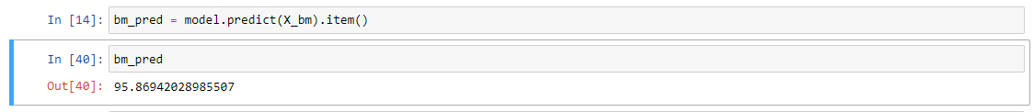



The features that came up as most important in our models (our chosen random forest model and the discarded linear regression model) included: vertical_drop, Snow Making_ac, total_chairs, fastQuads, Runs, LongestRun_mi, trams and SkiableTerrain_ac. Considering the importance of those features in our modeling, we also modeled a few scenarios in which we can further increase our revenue by either cutting or adding facilities and adjusting our ticket prices appropriately. We narrowed it down to four possible scenarios, and we made the assumption that the average customer buys a 5 day pass.

The first was to permanently close down up to 10 of the least used runs. What we found was as follows: Closing one run makes no difference; Closing 2 and 3 reduces support for ticket price and revenue; Closing 4 or 5 runs results in no further loss in ticket price from closing just 3 runs; Closing 6 or more runs leads to a large drop.

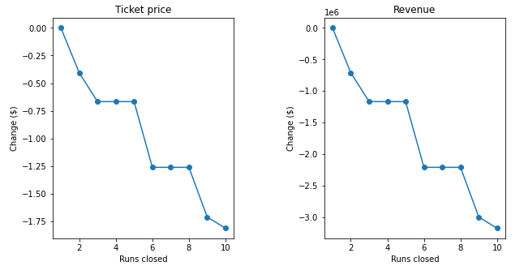

In the second scenario, Big Mountain would add a run, increasing the vertical drop by 150 feet, and install an additional chair lift. We found this would increase support a ticket price by $1.99, which over the course of a season would amount to an additional $3,474,638.

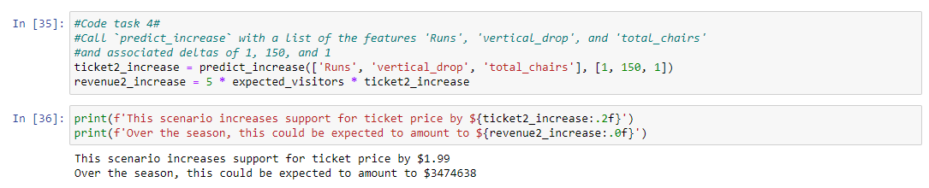

In the third scenario, we repeated the second scenario and added 2 acres of snow making. This made no difference from the second scenario.

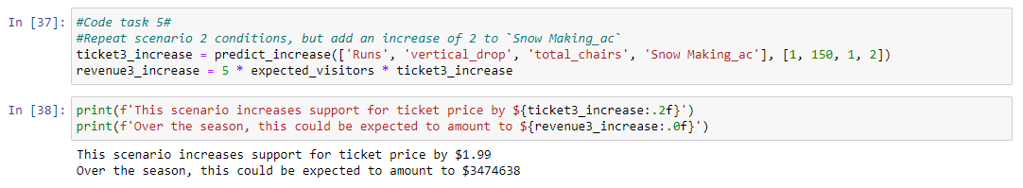

In the fourth scenario, we increased the longest run by .2 miles and added 4 acres of snow making capability. This made no difference in our model.



The recommendation would be to increase ticket price to $95.87. It is also worth considering scenario 2 of adding a run, increase vertical drop by 150 feet and installing an additional chairlift, which justifies add an additional $1.99 to the ticket price. However, without knowing the additional operating costs of this scenario, it is hard to recommend. As previously mentioned, our recommended ticket price increase to $95.87 came with a mean absolute error of $10.39, so there is some wiggle room in there which might depend on the additional data not contained here. Additional data that might be useful would be current operating costs, profit margin, quality and quantity of lodging and dining in the area, nearby attractions, proximity to major cities and transportation (highways, airports, etc.) and a breakdown of who is buying tickets (locals, out of state, international, etc.).